# Kitchen minute timer

## Schematic description

This construction measures the time in range 1 to 17 minutes. It blinks red LED and beeps after the time is up. The construction is based on 4000 family logical circuits. Time base is created by 4060 circuit with crystal oscillator. It generates 2Hz frequency at its output. This frequency is used for red LED and piezo buzzer. 2Hz frequency is divided by 4040 counter (U3) to 1 second period for yellow LED D10 (operation indication) and 1 minute period using 4 input AND circuit based on D5 to D8 diodes and resistor R7.

1 minute period is used as and input for Johnson counter 4017 (U4). There is another counter of the same type connected in cascade. This combination allows counting up to 17 minutes.

Minute timer is set using button SW2. It generates pulses for first counter U4 and it also resets minute divider U3. Button SW1 is used for reset the whole circuit back to 17 minutes.

LED D3 blinks and piezo buzzer beeps after the time is up. Counters stops counting until SW1 button is pressed (reset) – U5 CKEN input is blocked.

## Construction

U1 to U5 shall be populated first. The reason for that is to have a good access to IC terminals that can be blocked by passive components. Then continue by populating all passive components (resistors and capacitors). Diodes D1, D2, D5 to D9 and crystal Y1 shall be populated next. Then buttons SW1, SW2 and switch SW3 are soldered. Caution – take care of SW3 orientation (see photo).

LEDs are populated at the end. Please them to plastic spacers. Always solder one LED terminal, align it and then solder second terminal.

Battery holders are soldered at the bottom side. Take care of the polarity!

## How to get it into service

It should work on the first try when everything was soldered well. Yellow LED should blink after power up. Green LEDs should shift up to 1 minute by pressing SW2 button. Then red LED should blink and piezo buzzer should beep.

## Bill of material

|  |  |  |
| --- | --- | --- |
| **Annotation** | **Type** | **Qty** |
| BT1,BT2 | DS1092-10-W6L | 2 |
| BZ1 | Buzzer | 1 |
| C1,C4,C5,C6,C7,C8,C10,C11 | 100n | 8 |
| C2 | 100p | 1 |
| C3 | 22p | 1 |
| C9 | 47p | 1 |
| D1,D2,D5,D6,D7,D8,D9 | LL103A | 7 |
| D3 | 3mm R | 1 |
| D10 | 3mm Y | 1 |
| D11,D12,D13,D14,D15,D16,D17,D18,D19,D20,D21,D22,D23,D24,D25,D26,D27 | 3mm G | 17 |
| Q1 | BC848 | 1 |
| Q2 | BC858 | 1 |
| R1 | 10M | 1 |
| R2,R6,R10,R30 | 100k | 4 |
| R3,R4,R7,R8,R11,R12 | 10k | 6 |
| R5,R9,R13,R14,R15,R16,R17,R18,R19,R20,R21,R22,R23,R24,R25,R26,R27,R28,R29 | 680R | 19 |
| SW1,SW2 | 6mm | 2 |
| SW3 | PS-22E07L | 1 |
| U1 | 4081 | 1 |
| U2 | 4060 | 1 |
| U3 | 4040 | 1 |
| U4,U5 | 4017 | 2 |
| Y1 | 32768Hz | 1 |

## Button orientation

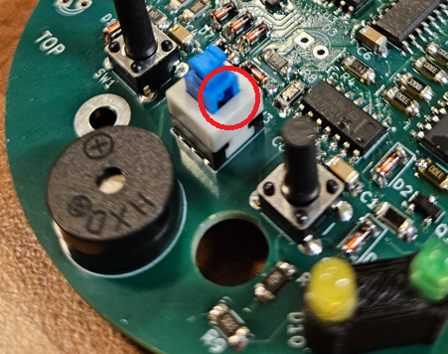

## Assembly

## Schematic

